- Introduction

  - Wireless Sensor Networks

A wireless sensor network (WSN) is a wireless network that contains distributed independent sensor devices that are meant to monitor physical or environmental conditions. A WSN consists of a set of connected tiny sensor nodes, which communicate with each other and exchange information and data.

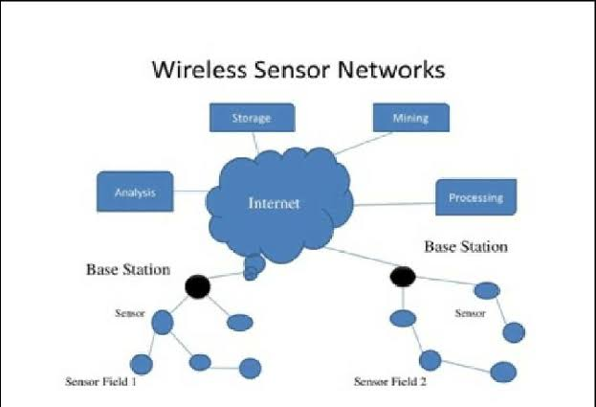

  - Comparison Critia

We focus on a set of criteria to compare existing related works (Figure 2). We divide these criteria into four groups: design environment, power supply design, reconfiguration scenario, and nonfunctional property (NFP) verification. In this study, we focus on modeling constraints and requirements typically imposed in terms of energy efficiency and reconfiguration in which we are interested for our future work.
1.2.1 Design environment
This group includes the design abstraction level. We are interested to define if the approach is MDE-based or developed at a low abstraction level. This group defines the modeling standards and techniques. We focus on the use of the UML/MARTE standard and definition and application of WSN design patterns.

    - Power supply design

This group focuses on the modeling of the WSN power supply section. It is an important criterion to be considered since power resources in WSN applications present a primary concern. This group includes the support of a typical power supply section using a local battery. It includes also the modeling of an energy harvesting power supply unit while an energy harvesting alternative [15, 16] is a promising solution to meet the network energy requirements

    - Reconfiguration scenario
This group focuses on the level and structure of reconfiguration engines. It includes two reconfiguration scenarios and the MAPE (Monitor, Analyzer, Planner, and Executor) loop modules [17]. Indeed, two reconfiguration scenarios are adopted in WSN applications [18]. The first scenario is the node-level-based reconfiguration, which corresponds to hardware and software reconfiguration. The second scenario is the network-level-based reconfiguration, which consists in modifying the network topology. The general structure of the reconfiguration engine is based on the MAPE loop

    - NFP verification
this group focuses on the support of temporal verification and performance evaluation. It includes works that used transformations from system models to simulation or analysis tool models in order to perform early WSN analysis

- Low-Level-Based Approaches for WSN Development.
Several research works have been contributed in the literature to develop and design WSN systems and their requirements. In the present section, discuss different low-level-based approaches for WSN. We classified those works into three categories: node-level abstraction, group-level abstraction, and network-level abstraction approaches.
1.Node-Level Abstraction Approaches.
In node-level abstraction, programmers decompose the global application into a set of local node behaviors where an explicit code is running on each node. Virtual machine approaches and embedded operating systems (Oss) are often used in this methodology. OS-based programming focuses on abstracting hardware allowing a flexible control of hardware resources of WSN application. TinyOS [19] (implemented with the programming language nesC [20]) and Contiki [21] are known Oss for WSNs used for the node-level abstraction. Both operating systems support WSN requirements, but there are differences. While TinyOS is better when resources are limited and power applications are low, Contiki is the best choice when flexibility is needed. The development of Oss for wireless sensor devices has been considered a key element for the IoT systems [22]. Several Oss are proposed in this context such as RIOT [23], Mbed OS [24], or FreeRTOS [25], which offer preemptive priority-based task schedulers, include full real-time support, and facilitate IoT application development. Mate [26] is a known virtual machine in WSNs. This project focuses on the need for new programming examples to overcome WSN constraints such as limited energy supply and limited bandwidth. A virtual machine approach provides the dynamic reprogrammability, but it suffers from the overhead that the instructions introduce. Several simulator environments are used for WSN research [27, 28]. The most cited is the NS-3 simulator which is a discrete-event simulator. NS-3 [29, 30] was developed in the C++ programming language, with an optional Python [31] scripting interface. Besides the scalability and performance improvements, simulation nodes have the ability to support multiple radio interfaces and multiple channels. Furthermore, NS-3 supports a real-time schedule that makes it possible to interact with a real system.
2.Group-Level Abstraction Approaches.
Each node associated with a group-level programming entity is considered a neighbor node for other nodes in the same network. When nodes are grouped based on physical closeness (geographical distance, number of communication hops, etc.), the group is called a neighborhood-based group, such as in Hood [32] and Abstract Region [33] that are examples of neighborhood programming abstractions for WSNs. These algorithms provide local data processing within a neighborhood. Hood provides support to design distributed algorithms in terms of the neighborhood abstraction. It uses data sharing to support scalability and collaboration. It employs a caching technique to save energy, reduces communication failures between nodes, and uses mirror to reflect time synchronization. Abstract Region provides interfaces for identifying neighboring nodes, sharing data, and data reduction within local neighborhoods. Power consumption and scalability are supported through data sharing.
3.Network-Level Abstraction Approaches.
In the network-level abstraction (called also macroprogramming), the whole sensor network is treated as a single system describing the global behavior. TinyDB [7] views the whole network as a database system. It allows users to issue queries in a declarative SQL-like language. For achieving energy efficiency, TinyDB focuses on when, where, and how to sample and deliver the data. TinyDB also optimizes the routing tree for disseminating a query and collecting the results. Moreover, there are limitations of database abstraction; for example, the use of only one table accessible on time is not favorable for heterogeneous sensors. Regiment [11] is a functional language specially designed for macroprogramming sensor networks that allows the direct use of a program state used to represent the finding of each individual node. Kairos [36], another example of programming abstraction, allows macroprogramming. It uses a caching technique to reduce power consumption and communications.

- High-Level-Based Approaches for WSN Development
The use of modeling techniques and languages involves the WSN design at higher abstraction levels, facilitates analysis steps, and resolves problems before deployment. The main motivation for applying high-level-based approaches is that new applications can be created with less effort than in traditional approaches. In the present section, we present firstly some existing component-based approaches for modeling WSN. Then, we recall WSN approaches based on the MDE methodology.
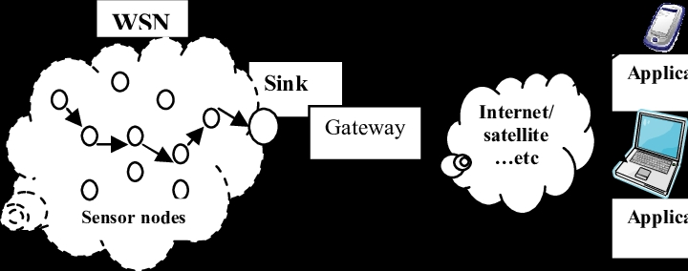

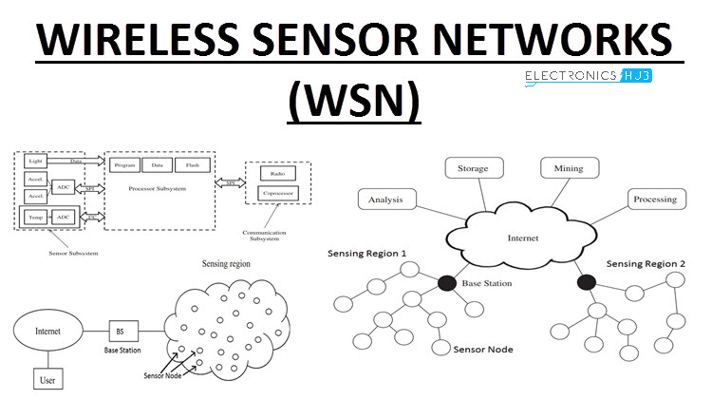

4.Component-Based Approaches
Many of modeling techniques support components to model the system because component-based modeling offers great abstraction by providing interface-based interaction between elements. We examine for each approach its modeling language, scopes, and elements
  - High-Level SDL Models (HL-SDL)
  - In [37], authors represented the HL-SDL modeling language that uses the Specification and Description Language (SDL) [38] to model, simulate, and verify communication protocols. SDL is used to model the component-based architecture of TinyOS using the SDL process. The system is modeled as a collection of processes and channels. The SDL approach provides the modeling of node behaviors and does not permit the modeling of the network architecture. Moreover, the generated code is created manually by the designer.
4.2 Insense
Authors proposed the Insense language in [39] for supporting a component-based model for WSN applications. Components can be hardware or software entities of sensor nodes, and they communicate synchronously via directional channels which abstract over communication and synchronization. This technique does not support the modeling of a WSN system architecture.
4.3 SensorML
Authors introduced the SensorML [40] language in order to provide support for modeling sensor specifications such as physical location, hardware, and sensor type. In the SensorML model, components are represented as processes linked together through inputs and outputs. The model includes physical elements such as sensors and actuators and nonphysical components such as mathematical equations. SensorML supports the modeling of different elements of the network. But it lacks support for testing and validating the design before its real deployment.
4.4 UM-RTCOM
The UM-RTCOM model, which is developed in [41], presents a component framework for developing wireless sensor and actor network applications. This model contains sensors, actors, and a coordinator. The communication between sensors and actors and between actors and a coordinator is via channels which are modeled as a tuple that allows one-to-many and many-to-one communication. The UM-RTCOM model provides three types of components: generic components, active components, and passive components. The UM-RTCOM model performs different kinds of analysis such as liveness property, real-time, and deadlock freedom.

6. Summary and Future Work

In this paper, we presented a study about programming methodologies and modeling techniques for WSN development. We classified those works into two categories according to the abstraction level of their design. The first category concerned low-level techniques for WSN and particularly programming models. The second category dealt with high-level-based approaches including component-based modeling techniques and MDE-based approaches and particularly those that used UML and MARTE standards and pattern-based concepts. Table 1 summarizes the previous sections by illustrating a comparison of the discussed related works.
We conclude from our study that the development of WSN can be investigated at different abstraction levels. Various development techniques have been presented at low abstraction level to address either the node behavior or the network architecture [7, 19, 21]. These approaches have proven their effectiveness for developing WSNs; however, there is a lack of standard mechanisms that fit with WSN complexity. Therefore, raising the abstraction level is a promising solution to handle the shortcomings of low-level-based approaches. In fact, MDE and specifically the MARTE profile have received enormous attention in WSN development. The UML/MARTE profile offers the modeling of hardware and software elements of the WSN system. Table 2 illustrates how existing high-level approaches have applied UML concepts and MARTE stereotypes to model WSN elements.

References
- N. K. Suryadevara, S. C. Mukhopadhyay, S. D. T. Kelly, and S. P. S. Gill, “WSN-based smart sensors and actuator for power management in intelligent buildings,” IEEE/ASME Transactions on Mechatronics, vol. 20, no. 2, pp. 564–571, 2015.View at:
- M. P. Durisic, Z. Tafa, G. Dimic, and V. Milutinovic, “A survey of military applications of wireless sensor networks,” in 2012 Mediterranean Conference on Embedded Computing (MECO), pp. 196–199, Bar, Montenegro, June 2012.View at:
- H. Furtado and R. Trobec, “Applications of wireless sensors in medicine,” in 2011 Proceedings of the 34th International Convention MIPRO, pp. 257–261, Opatija, Croatia, May 2011.View at:
- I. F. Akyildiz, W. Su, Y. Sankarasubramaniam, and E. Cayirci, “Wireless sensor networks: a survey,” Computer Networks, vol. 38, no. 4, pp. 393–422, 2002.View at:
- L. Mottola and G. P. Picco, “Logical neighborhoods: a programming abstraction for wireless sensor networks,” in Distributed Computing in Sensor Systems. DCOSS 2006. Lecture Notes in Computer Science, vol 4026, P. B. Gibbons, T. Abdelzaher, J. Aspnes, and R. Rao, Eds., pp. 150–168, Springer, Berlin, Heidelberg, 2006.View at:
- Q. Jiang and D. Manivannan, “Routing protocols for sensor networks,” in First IEEE Consumer Communications and Networking Conference, 2004. CCNC 2004, pp. 93–98, Las Vegas, NV, USA, January 2004.View at:
- S. R. Madden, M. J. Franklin, J. M. Hellerstein, and W. Hong, “Tinydb: An acquisitional query processing system for sensor networks,” ACM Transactions on Database Systems, vol. 30, no. 1, pp. 122–173, 2005.View at:
- M. M. Molla and S. I. Ahamed, “A survey of middleware for sensor network and challenges,” in 2006 International Conference on Parallel Processing Workshops (ICPPW'06), pp. 6–228, Columbus, OH, USA, August 2006.View at:
- R. C. Shit, S. Sharma, D. Puthal, and A. Y. Zomaya, “Location of things (lot): a review and taxonomy of sensors localization in Iot infrastructure,” IEEE Communications Surveys & Tutorials, vol. 20, no. 3, pp. 2028–2061, 2018.View at:
- R. C. Shit, S. Sharma, D. Puthal et al., “Ubiquitous localization (UbiLoc): a survey and taxonomy on device free localization for smart world,” IEEE Communications Surveys & Tutorials, vol. 21, no. 4, pp. 3532–3564, 2019.View at:
- R. Newton, G. Morrisett, and M. Welsh, “The regiment macroprogramming system,” in 2007 6th International Symposium on Information Processing in Sensor Networks, pp. 489–498, Cambridge, MA, USA, April 2007.View at:
- D. C. Schmidt, “Guest editor’s introduction: model-driven engineering,” Computer, vol. 39, no. 2, pp. 25–31, 2006.View at:
- OMG Object Management Group, A UML Profile for MARTE: Modeling and Analysis of Real-Time Embedded Systems, ptc/2011-06-02, Object Management Group, 2011.
- J. Vlissides, R. Helm, R. Johnson, and E. Gamma, Design patterns: elements of reusable object-oriented software, Reading: Addison-Wesley, 1995.
- F. K. Shaikh and S. Zeadally, “Energy harvesting in wireless sensor networks: a comprehensive review,” Renewable and Sustainable Energy Reviews, vol. 55, pp. 1041–1054, 2016.View at:
- S. Basagni, M. Y. Naderi, C. Petrioli, and D. Spenza, “Wireless sensor networks with energy harvesting,” in Mobile Ad Hoc Networking, Cutting Edge Directions, S. Basagni, M. Conti, S. Giordano, and I. Stojmenovic, Eds., pp. 701–736, John Wiley & Sons, 2013.View at:

